**Printed Circuit Board (PCB):**

PCB means printed circuit board PCB is one of the most important elements in any electronic system. They accomplish the interconnection the between component mounted on them in particular manner PCB consist of conductive circuit pattern which is applied to one or both sided of an insulating base copper is most widely used for conductor material. Aluminum nickel, silver, brass is used for same special application.

The thickness of conducting material depends upon the current carrying capacity of circuit. Thus a thicker conductor layer will have mare current carrying capacity once the PCB is manufactured the current carrying capacity is depends on which of conductor track.

**FUNCTION: -**

The printed circuit board usually serves there distinct functions are as follows:

* It provides mechanical support for the component mounted on it.
* It provides necessary electrical interconnections.
* It acts as a heat sink i.e. it provides a conduction path leading to removal of most of the heat generate in the circuit.

**Advantage of PCB: -**

Over the conventional wire method:

* PCB’s have controllable and predicable electrical mechanical properties.
* Rapid production is possible.
* Time is saved since it avoids wiring connections production to another
* Weight is reduced.
* Soldering is done in one operation instead of individual connection between component and wires.
* Cost is less.

**TYPES OF PCB:**

* Single sided PCB.
* Double sided PCB.
* **Single Sided PCB: -**

This type of PCB consists of a natural coil of a copper on only one side of the base material. This type of PCB frequently used when the manufacturing cost has to be kept at minimum.

* **Double Sided PCB: -**

Double sided PCB is used when there is more number of jumpers. This type of PCB has copper fail on both side of base material. The double-sided PCB’s are used when insulation of PCB is very complicated i.e. if jumpers are more in number and when it is difficult to fabricants the PCB ON a single sided PCB.

The various steps involved in PCB.

Preparations are:

* **Layout planning**
* **Artwork drawing**
* **Artwork transforming**
* **Painting**
* **Etching**
* **Drilling**
* **Soldering**
* **Mounting of component**
* **Testing**
* **Protection**
* **ADVANTAGE:**

The most important advantage of this system is to make the system independent of on-board processing which uses most of the battery power as well as the independency of each module makes it easier for upgrade to new feature. The wireless feature makes it useful to work from a distant location with virtually controlling.

**SOFTWAER REQUIRMENT –**

* MPLAB IDE 8.91
* EMBEDDED C LANGUAGE
* PIC KIT3 PROGRAMMER
* PCB WIZARD (LAYOUT)
* PROTEL SE 99 (CIRCUIT DIA.)

**Software development:**

PIC is a family of microcontrollers manufactured by [Microchip Technology Inc](http://www.microchip.com/). PIC stands for **Peripheral Interface Controller**. It is also referred to as **Programmable Interface Controller** or **Programmable Intelligent Computer**.

[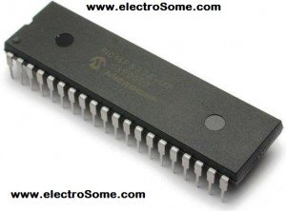](https://electrosome.com/wp-content/uploads/2012/06/PIC16F877A.jpg)As all other microcontrollers PIC Microcontroller can be programmed using Assembly Language. As it is little bit difficult we prefer High Level Languages. Many high level language compilers are available for programming a PIC Microcontroller like MikroC, MPLAB XC8, Hi-Tech C, CCS C etc. In this tutorial we will use CCS C Compiler. CCS stands for Custom Computer Services, a Microchip PIC Microcontroller Tool Solutions company.

MikroC and CCS C are the best compilers for beginners as they includes a lot of built in libraries which enable us to program a PIC Microcontroller without the deep knowledge of its internal architecture. I think CCS C is the best High Level Language Compiler for PIC Microcontroller as it is almost hardware independent.

MPLAB X IDE is a software program that runs on a PC (Windows®, Mac OS®, Linux®) to develop applications for Microchip microcontrollers and digital signal controllers. It is called an Integrated Development Environment (IDE), because it provides a single integrated "environment" to develop code for embedded microcontrollers.

MPLAB X Integrated Development Environment brings many changes to the PIC® microcontroller development tool chain. Unlike previous versions of the MPLAB IDE which were developed completely in-house, MPLAB X IDE is based on the open source NetBeans IDE from Oracle. Taking this path has allowed us to add many frequently requested features very quickly and easily, while also providing us with a much more extensible architecture to bring you even more new features in the future.

1. **Open MPLAB IDE v8.56**
2. **From the 'Projects' tab, select the first option 'Project Wizard'**
3. **Click on 'Next' in the welcome window that appears.**
4. **Select the desired PIC which you need to program or build your project on and click on 'Next'**
5. **Select the active tool suite you require; among the list of tool suites given (Usually the HI-TECH Universal tool suite is preferred,if installed)**
6. **Check if the ToolSuite contents listed contains a compiler suiting your programming needs("HI-TECH ANSI C Compiler" in the case of a HI-TECH Universal toolsuite) and click 'Next'**
7. **Create a new project file at your desired location in the desired name.**
8. **Take care that the project file is saved in the '*.mcp' format and click 'Next'**
9. **In the next window , add any files you desire to add to your new project,if required.** else just skip this step by clicking 'Next'.
10. **Now click 'finish' and your new project is created.**
11. **Now select the 'New' option from the 'File' tab.v**

**Select 'Save as' option from the 'File' tab and save the new file in the same folder in which you have created the project by selecting a suitable option from 'save as type'(depending on which type of program you're doing)**

1. **Go to the 'Project' tab and select the option 'Add Files To The Project' and add the file saved in the previous step** you're doing programming in C
2. Assembly Source Files if you're doing programming in ASSEMBLY language etc...
3. **Begin programming in the file.**

**Embedded C**

Embedded C is a set of language extensions for the C Programming language by the C Standards committee to address commonality issues that exist between C extensions for different embedded systems. Historically, embedded C programming requires nonstandard extensions to the C language in order to support exotic features such as fixed-point arithmetic, multiple distinct memory banks, and basic I/O operations. Embedded C uses most of the syntax and semantics of standard C, e.g., main() function, variable definition, datatype declaration, conditional statements (if, switch, case), loops (while, for), functions, arrays and strings, structures and union, bit operations, macros, etc.

**Features:-**

1. It is small and simpler to learn, understand, program and debug.
2. Compared to assembly language, C code written is more reliable and scalable, more portable between different platforms.
3. C compilers are available for almost all embedded devices in use today, and there is a large pool of experienced C programmers.
4. C has advantage of processor-independence and is not specific to any particular microprocessor/microcontroller or any system.
5. As C combines functionality of assembly language and features of high level languages.
6. It is fairly efficient.
7. It supports access to I/O and provides ease of management of large embedded projects.

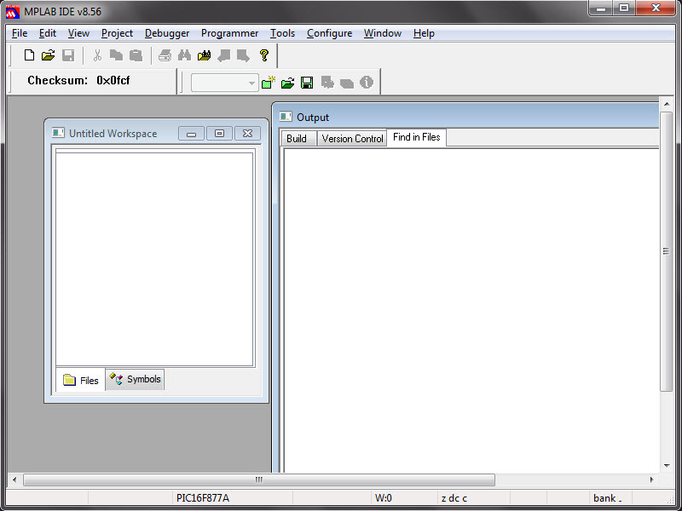

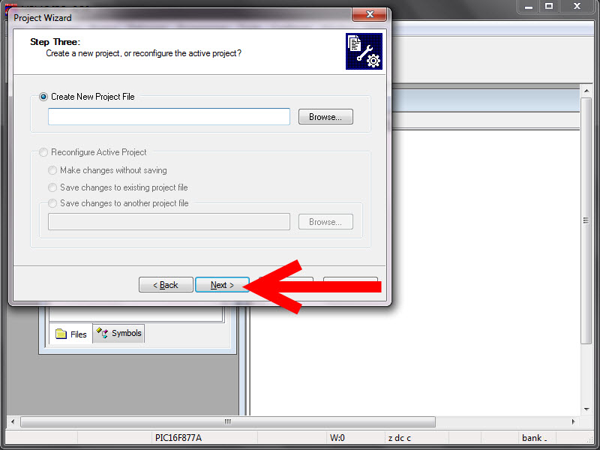

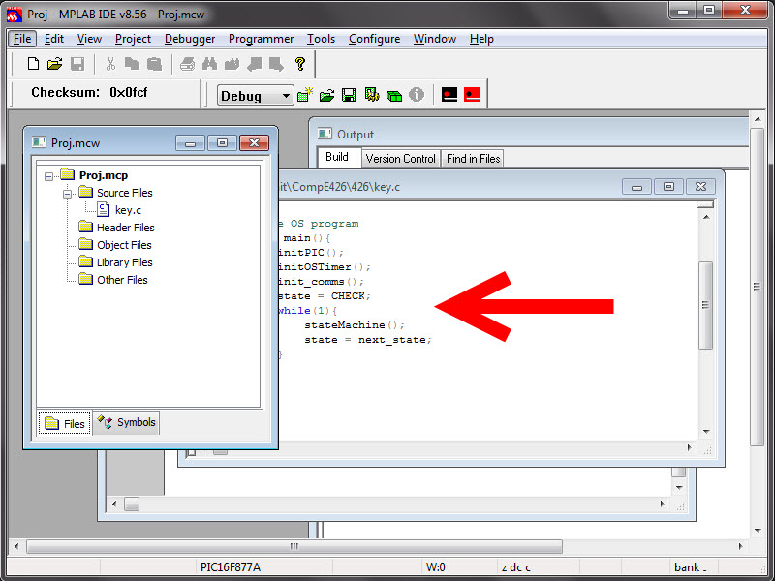

**Programmer:**

**Pic kit 3**

The MPLAB PICkit 3 allows debugging and programming of PIC® and dsPIC® Flash microcontrollers at a most affordable price point using the powerful graphical user interface of the MPLAB Integrated Development Environment (IDE). The MPLAB PICkit 3 is connected to the design engineer's PC using a full speed USB interface and can be connected to the target via an Microchip debug (RJ-11) connector (compatible with MPLAB ICD 2, MPLAB ICD 3 and MPLAB REAL ICE).HID interface, say no more driver again Support windows 7 system USB (Full speed 12 Mbits/s interface to host PC) Real-time execution MPLAB IDE compatible (free copy included)Built-in over-voltage/short circuit monitor  
Firmware upgradeable from PC/web download Totally enclosed Supports low voltage to 2.0 volts (2.0v to 6.0v range) Diagnostic LEDs (power, busy, error) Read/write program and data memory of microcontroller Erase of program memory space with verification Freeze-peripherals at breakpoint Program up to 512K byte flash with the Programmer-to-Go  
Material Plastic Housing Dimensions  
95 x 40 x 13 mm / 3.74 x 1.57 x 0.51 inch  
  
  
  
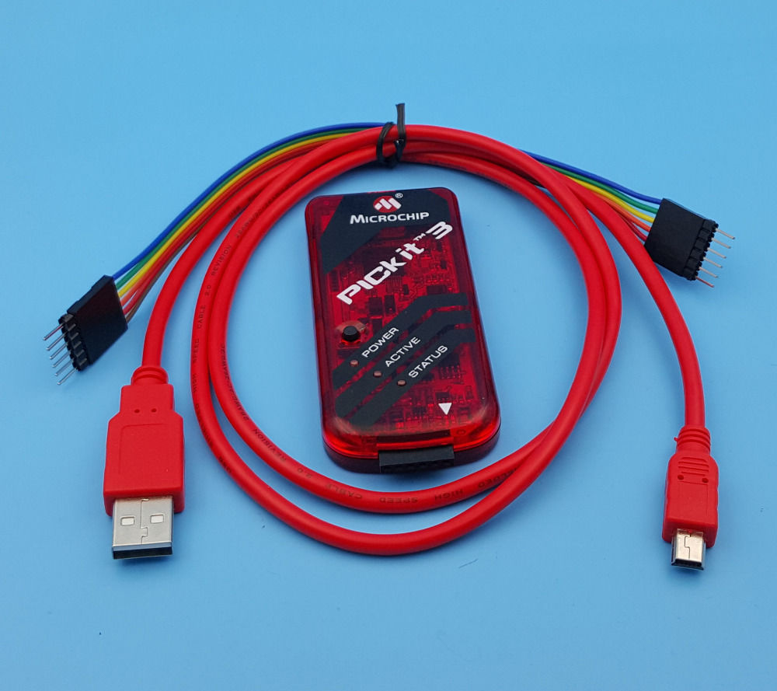

CCS COMPILER:

The CCS C Compiler for PIC10, PIC12, PIC14, PIC16, and PIC18 microcontrollers has 307 Built-in Functions to access PIC® MCU hardware is easy and produces efficient and highly optimized code. Functions such as timers, A/D, EEPROM, SSP, PSP, USB, I2C and more:

* Built-in libraries that work with all chips for RS-232 serial I/O, I2C, discrete I/O and precision delays.
* Serial I/O functions allow standard functions such as GETC() and PRINTF() to be used for RS-232 like I/O.
* Formatted printf allows easy formatting and display in HEX or decimal.
* Multiple I2C and RS232 ports may be easily defined.
* #use rs232() offers options to specify a maximum wait time for getc.
* Hardware tranceiver used when possible, but for all other occasions the compiler generates a software serial transceiver.
* Microcontroller clock speed may be specified in a PRAGMA to permit built-in functions to delay for a given number of microseconds or milliseconds.
* Functions such as INPUT() and OUTPUT_HIGH() properly maintain the tri-state registers.
* Compiler directives determine if tri-state registers are refreshed on every I/O or if the I/O is as fast as possible.
* [**#USE SPI ()**](https://www.ccsinfo.com/content.php?page=compiler-features#usespi)
* Simple functions like READ_ADC() to read a value from A/D converter.
* Source code drivers included for LCD modules, keypads, 24xx and 94xx serial EEPROM, X10, DS1302 and NJU6355 real time clocks, Dallas touch memory devices, DS2223 and PCF8570, LTC1298 and PCF8591 A/D converters, temperature sensors, digital pots, I/O expander and much more.
* 133 ready-to-run programs included.